Experiment 2: 4-bit Full Adder Experiment

Name: Infeter Md (尹飞翔)

Student ID: 202237026

Use a 1-bit full adder to implement a 4-bit serial carry parallel adder. Use this adder to perform the operation, and fill in Table 1 based on the operation result.

A4 A3 A2 A1 + B4 B3 B2 B1 + C1 = C5 S4 S3 S2 S1

**Table 1 Truth table of 4-bit serial carry parallel adder**

|  |  |  |  |  |
| --- | --- | --- | --- | --- |
| INPUT | | | OUTPUT | |
| A4 A3 A2 A1 | B4 B3 B2 B1 | C1 | S4 S3 S2 S1 | C5 |
| 0001 | 0010 | 0 | 0011 | 0 |
| 1001 | 1100 | 1 | 0110 | 1 |
| 0011 | 1011 | 0 | 1110 | 0 |
| 1011 | 1100 | 1 | 1000 | 1 |
| 0101 | 1010 | 0 | 1111 | 0 |
| 1100 | 0011 | 0 | 1111 | 0 |
| 1001 | 1100 | 1 | 0110 | 1 |
| 1010 | 0110 | 1 | 0001 | 1 |

You can check my circuit diagram as a proof

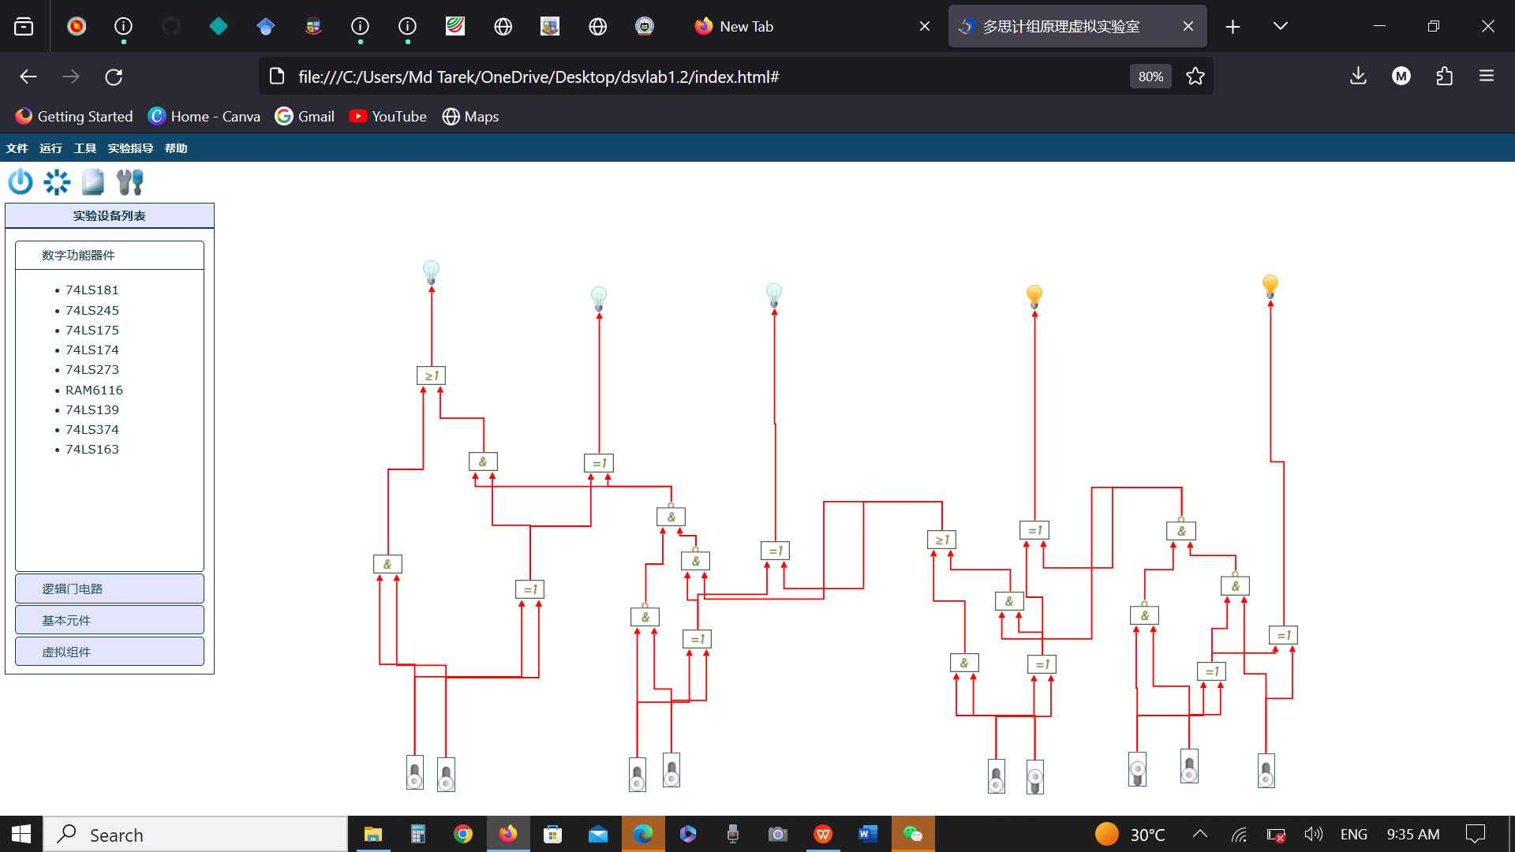

Figure: Pictures of the circuit and Output

NOTE:

1. Every experiment requires writing an experimental report.

1. The experimental report should include at least the experimental screenshot and the experimental results.

3 .The experiments require designing circuits and truth value tables by yourself.